**Software Requirements and Design Document**

**For**

**Group <24>**

Version 1.0

**Authors**:

Garett A

Daniel B

Cameron H

Jared U

# Overview

*A retro futuristic, cyberpunk platformer. It will feature crisp movement mechanics, enemies, abilities, and a unique boss as well as game modes. We’re looking to make a unique modern take on the old retro style games similar to Megaman, blending the mechanics of a 2D platformer with a shooter.*

# Functional Requirements

1. *Basic Player Movement - High*
2. *Advanced Player Movement - Medium*
3. *Basic Enemies and Enemy Logic - High*
4. *Player Attack - High*
5. *Player Abilities - Medium*
6. *A good map - Medium*
7. *Multiple maps - Low*
8. *Boss – Medium*
9. *Multiple Bosses - Low*
10. *High Scores – Low*
11. *Remappable Controls – Low*
12. *Sound Effects – Medium*
13. *Soundtrack – Low*
14. *Settings and Title Screen – High*

# Non-functional Requirements

1. *Computer needs python installed, as well as pygame*

# Use Case Diagram

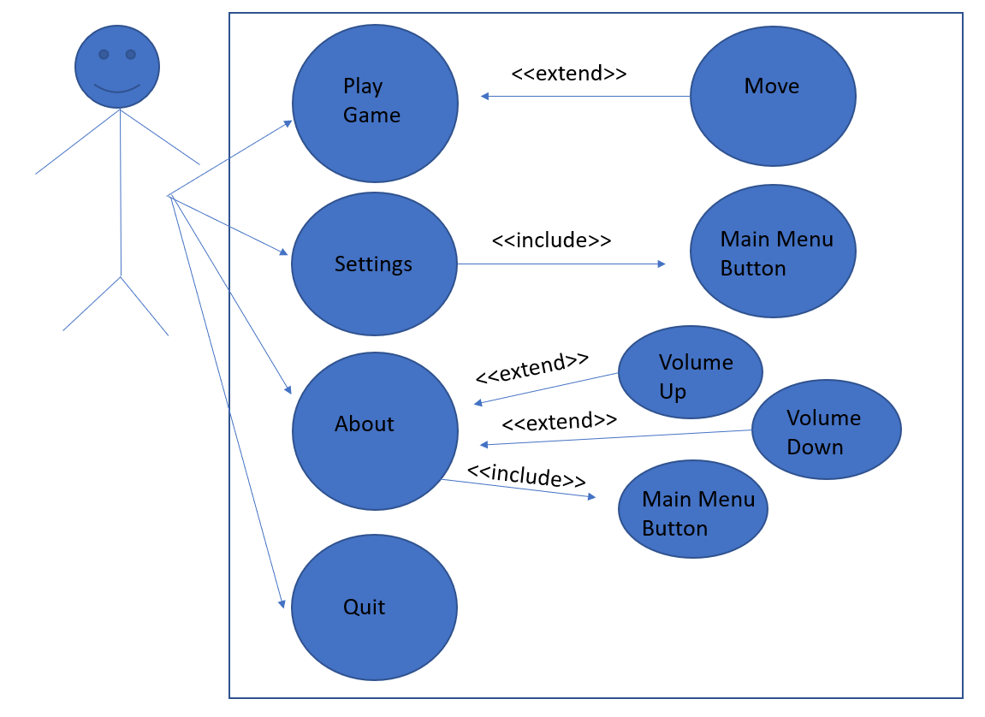

# Class Diagram and/or Sequence Diagrams

*If the main* ***paradigm*** *used in your project is* ***Object Oriented*** *(i.e., you have classes or something that acts similar to classes in your system), then draw the* ***Class Diagram******of the entire system and Sequence Diagrams for the three (3) most important use cases in your system.***

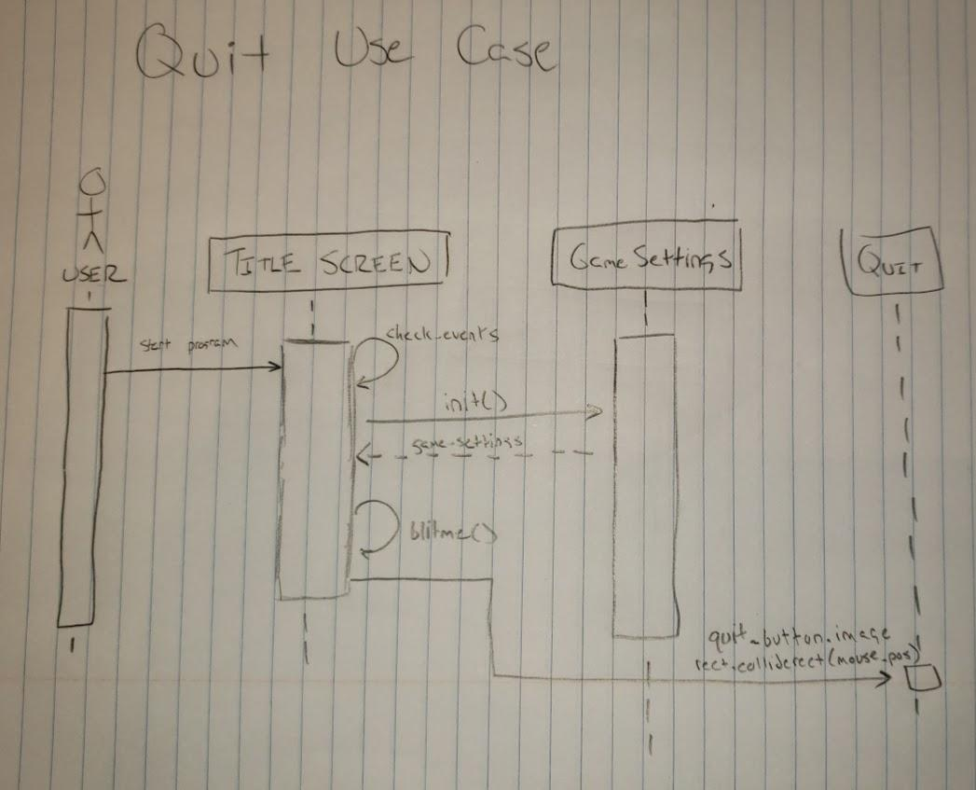

**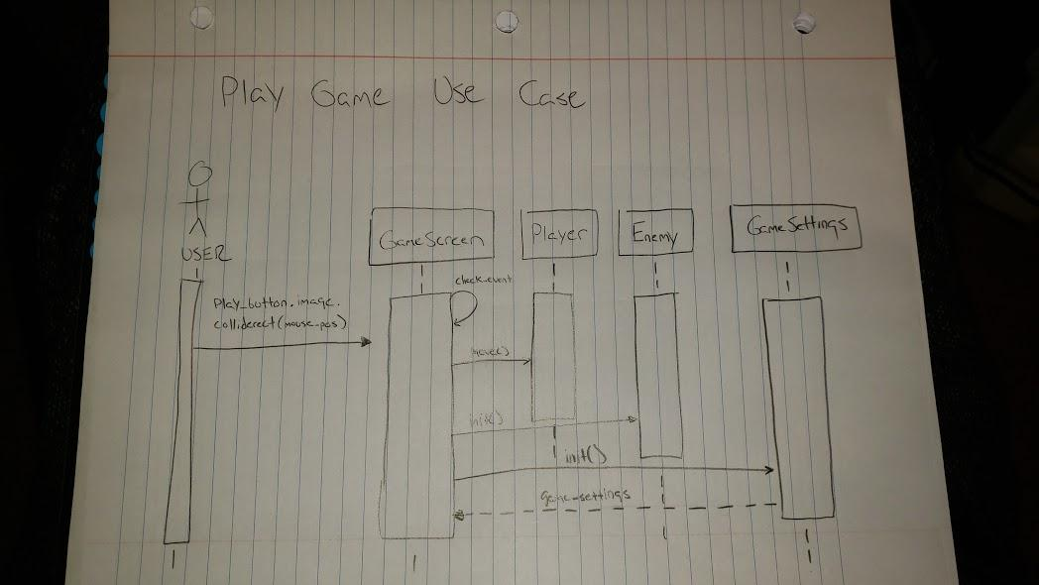***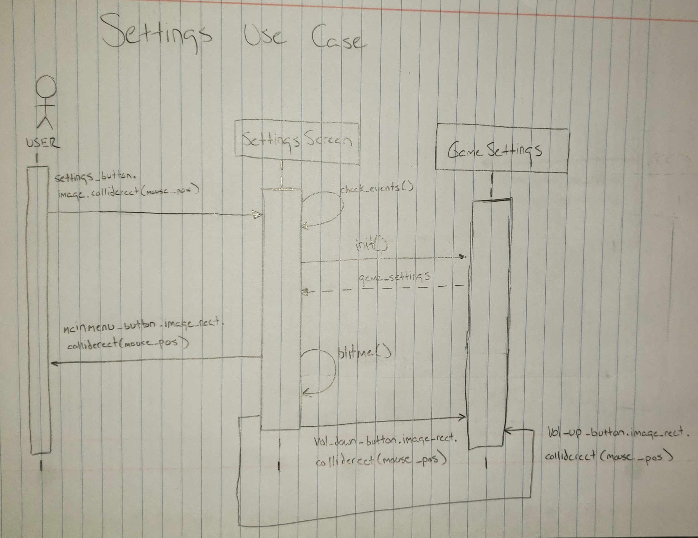*

# Operating Environment

1. *Any operating system compatible with python, computer must install python3 as well as pygame*

# Assumptions and Dependencies

1. We will be using free non copyrighted graphics and sounds downloaded from the internet. Since this is not essentially coding it isn’t relevant to the class project to create these ourselves, so we will be using available ones which match our projects vision.